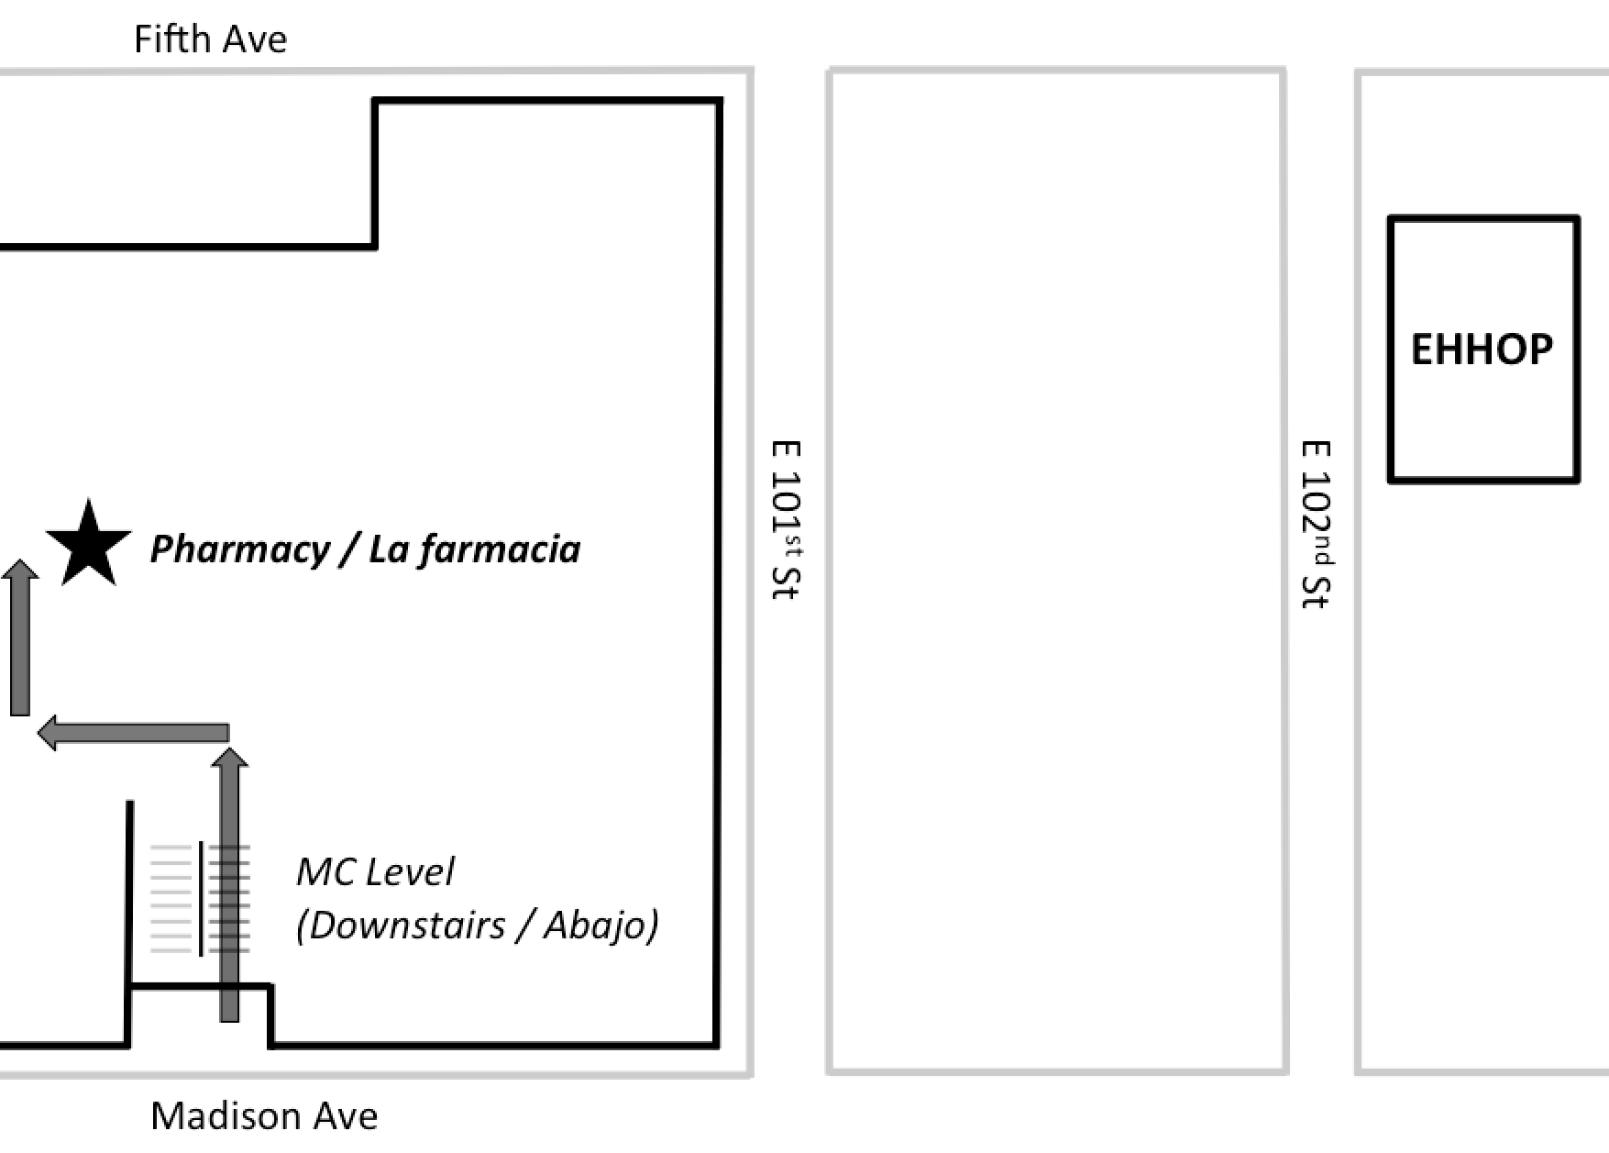
Pharmacy Refill Instructions

For refills, call
212-241-0485 and leave a message with the following information:

- Tell them you are an EHHOP Patient.
- Spell your last name, Spell your first name
- Medication name(s)
- Phone number

Your medications will be ready the next business day after you call. The pharmacy is open Monday to Friday from 8:30am to 5pm. If you go to the pharmacy without calling in advance, the pharmacy will not have your prescription ready for pick-up.

When you arrive at the pharmacy, please be patient. It may take some time for the pharmacist to retrieve your medications.

Medications
1. | 5.
2. | 6.
3. | 7.
4. | 8.
If you have any problems, you can call EHHOP at 877-372- 4161.

