Pulmonary Function Test Order Panels
Panel/Procedure name and ID | Order
PFT- Spirometry, Bronchodilator, Lung volumes, Diffusion – O230748 | Respiratory Flow Volume Loop aka Spirometry
 | Spirometry Pre/Post Bronchodilator
 | Plethysmography For Lung Volume/Airway Resistance
 | CO2/MEMBRANE DIFFUSE CAPACITY
PFT-Muscle Forces – O205306 | MVV, Maximum Voluntary Ventilation
 | MIP/MEP (Maximal Inspir/Expir Pressure)
Methacholine Challenge Test – O230744 | Methacholine Challenge Test
 | Bronchial Allergy Tests,Drugs
 | Methacholine Chloride, Neb
 | Airway Inhalation Treatment
Cardiopulmonary Exercise Test (CPET) – O230745 | Pulmonary Stress Testing,Complex (CPET)
 | Respiratory Flow Volume Loop
 | MVV, Maximum Voluntary Ventilation
High Altitude Simulation Test (HAST) - 94453 | High Alt Sim Test (Hast) W O2 Titrate
Sputum Induction – O230747 | Culture-AFB Respiratory
 | Airway Inhalation Treatment
Pulmonary Stress Test - Simple (O2 Assessment/6 Minute Walk Test) – O230746 | O2 Assessment
 | 6 Minute Walk Test
Nitric Oxide - 95012 | Nitric Oxide Expired Gas Determination
ABG (Arterial Blood Gas) - 36600 | Arterial Puncture, Withdrawal of Blood for Diagnosis

To Order Pulmonary Function Tests Using the Order Panels:
- Login to EPIC
- Open the patient from the schedule
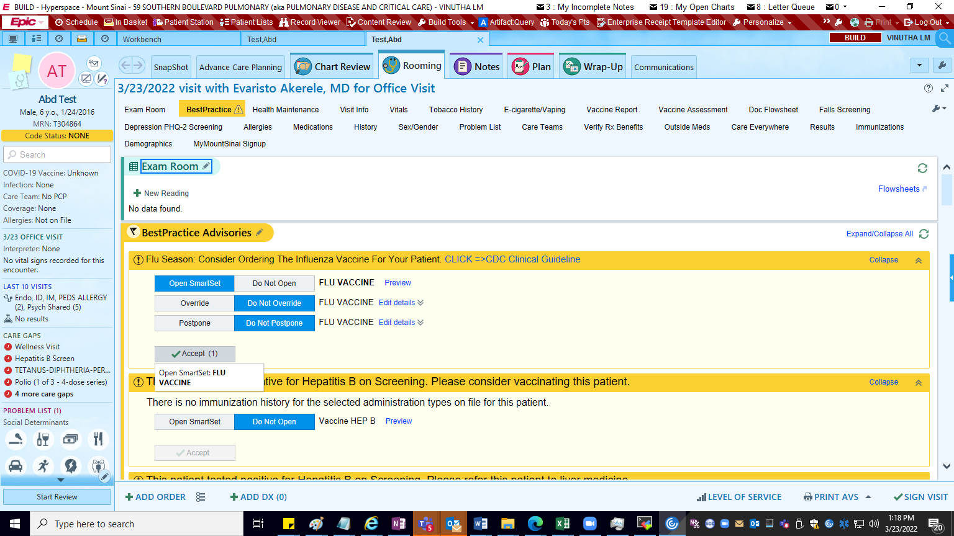

- Click on ‘ADD ORDER’ on the bottom of the page.
- Enter the name of the Panel or o<PanelNumber> (Letter o followed by panel number).
Example – Enter – ‘PFT-Muscle Forces’ or ‘o205306’ and hit enter

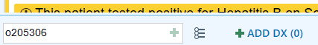

Or

- You will find the Panel added in the Facility List tab

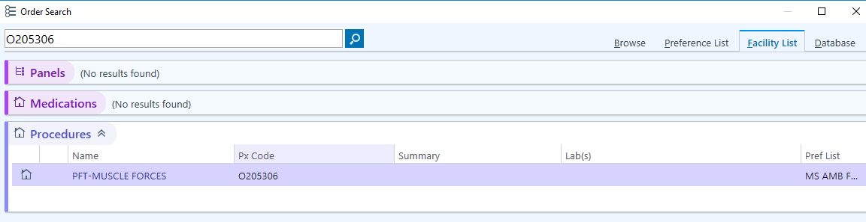

- Select the appropriate Order Panel and click on ‘Accept’ button at the bottom of the page.

- Once we accept this, the Orders in the Panel appear as below –
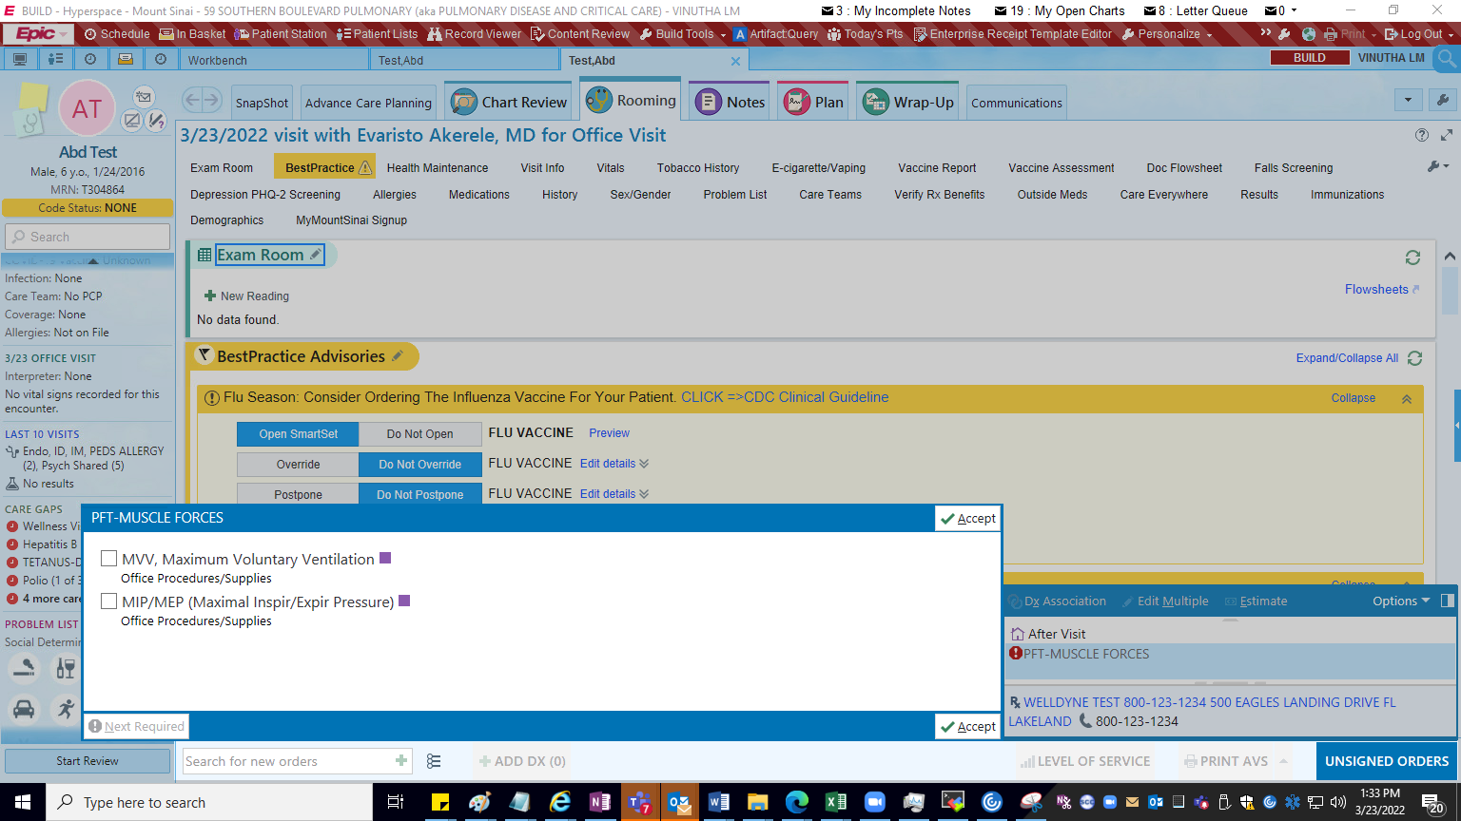

- Click on Each Order to fill the mandatory fields and then click on Accept button.
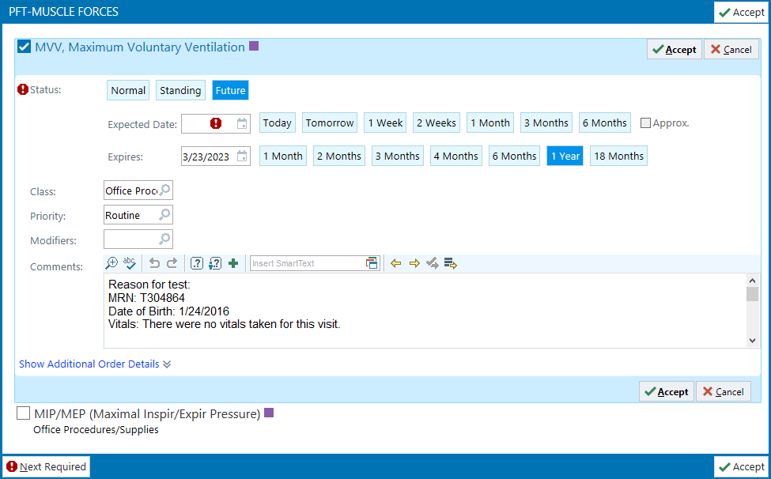

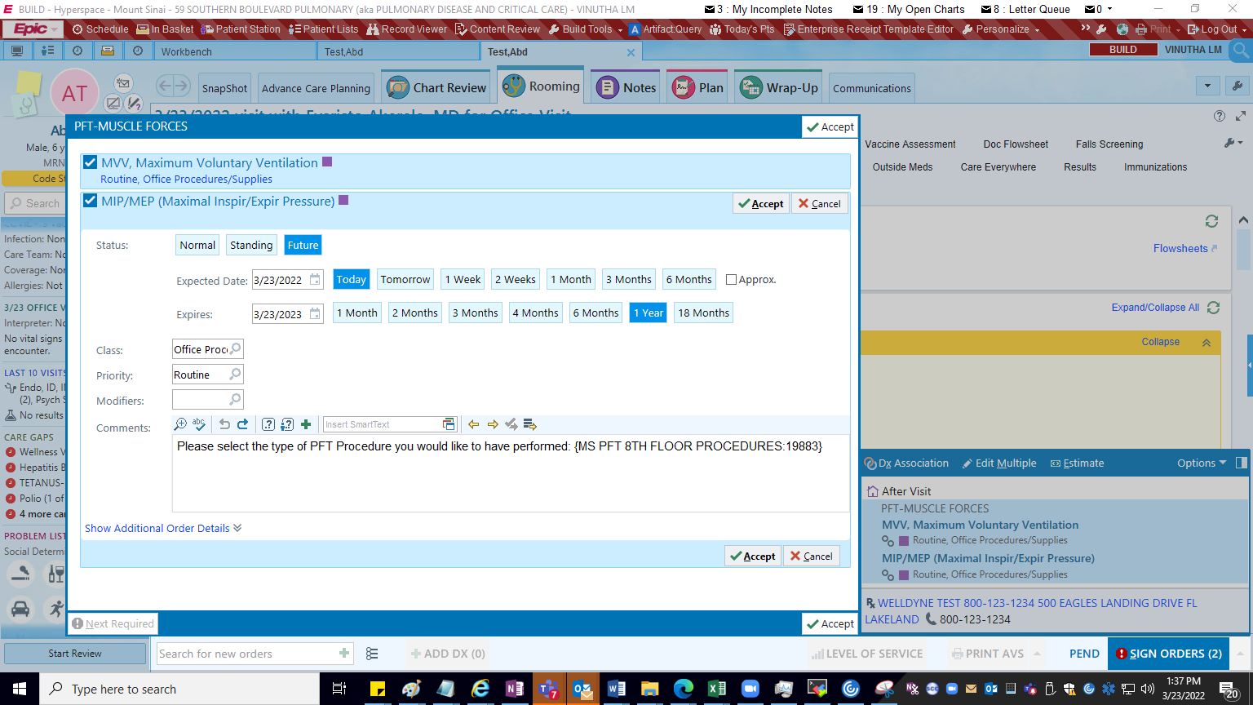

If you find any smart lists, like shown in the above image, type ‘F2’ key and select the values in the list.
Once you click on F2, use left click and right click on your mouse/keypad to select the value you desire. If you do not need this comment, please delete.
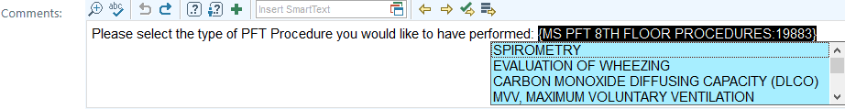

- Once you select the value, click on Accept on the Order and again click on Accept in the Order Panel

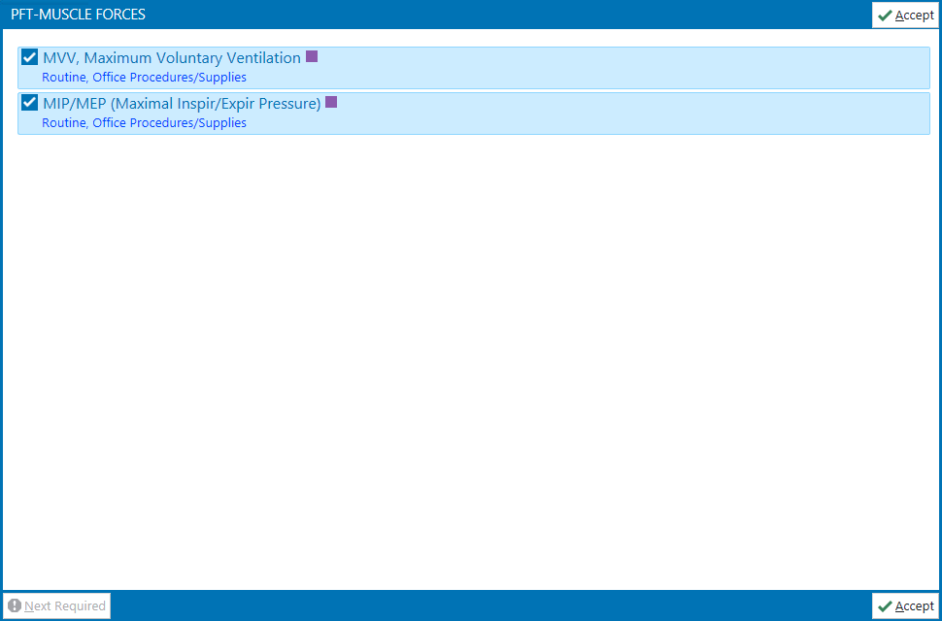

- Once you click on Accept, link these Orders to Diagnosis by using ‘Dx Association’ button.
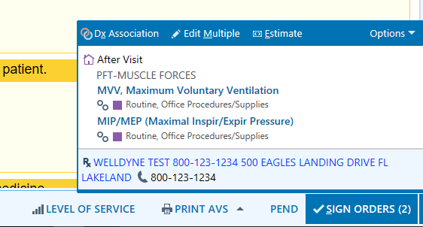

- Add diagnosis, then use the check box to link the diagnosis and Orders. Once done, click on Accept.
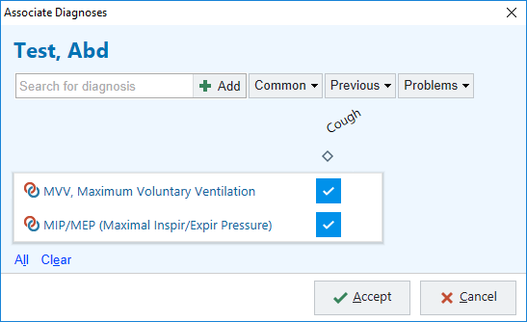

- Update any other mandatory fields and click on ‘Sign Encounter’ button on the bottom of the page to Sign the encounter. You an accordingly review and Sign the visit after all the validations are complete.

