For most patients, Insulin will already be in their medication list, so all you need to do is just refill that order (make sure the units are up-to-date and correct).

Most forms of insulin (long-acting, regular, rapid) have a concentration of 100units / mL. Each Kwikpen is 3mL. So with a concentration of 100 U/mL * 3mL = 300 units per 1 pen. However, the kwikpens are in boxes of 5, so you cannot prescribe 1 pen, you have to prescribe in factors of 5. (5 pens, 10 pens, 15 pens etc.).

Each box has a total of 1500 Units. (5 pens * 3ml * 100U/ml).

If a patient is on 10U/day then they would need 300 U/month (10U * 30 days). So a box (5 pens) would last them 5 months.

The pharmacy also carries alcohol swabs and pen needles
- For pen needles, pick this: BD ULTRA-FINE NANO PEN NEEDLE 32 GAUGE X 5/32" (aka 4MM 32 G). or just type in “pen needle 4mm”, and it’s the only result
  - Quantity: 100 each
  - Patient Sig: as directed
- For alcohol swabs, choose this:
  - 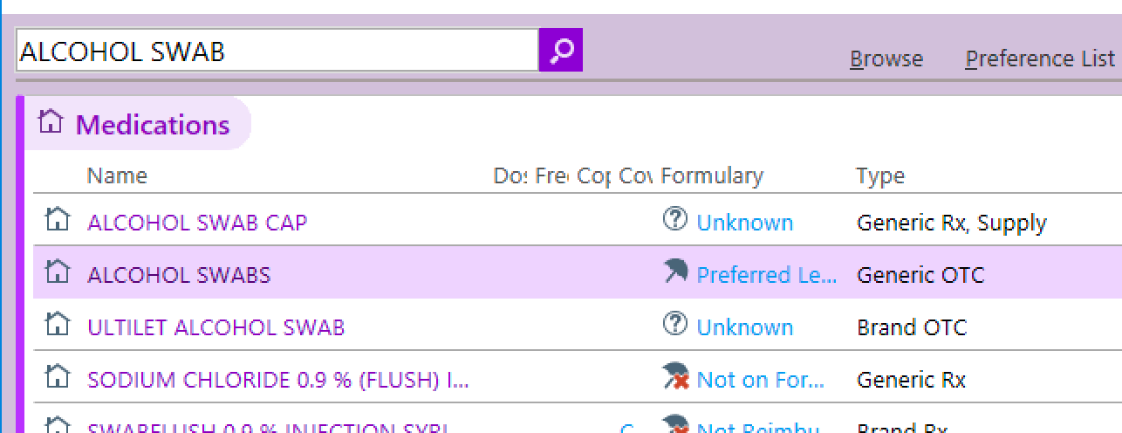
    - Quantity: 200 each
    - Patient Sig: as directed
  - You can also pick alcohol pad or alcohol prep pad.
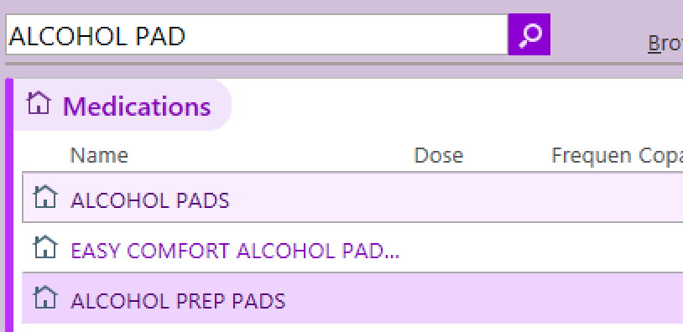

If your patient is starting Insulin or just doesn’t have Insulin on their medication list, you will have to start the prescription from scratch. See next page…

Writing an Insulin Prescription

For the majority of our patients, they will be started on Basaglar. If you search Basaglar, there is only one result that shows up. Pick that. It should be “Basaglar Kwikpen U-100 Insulin”

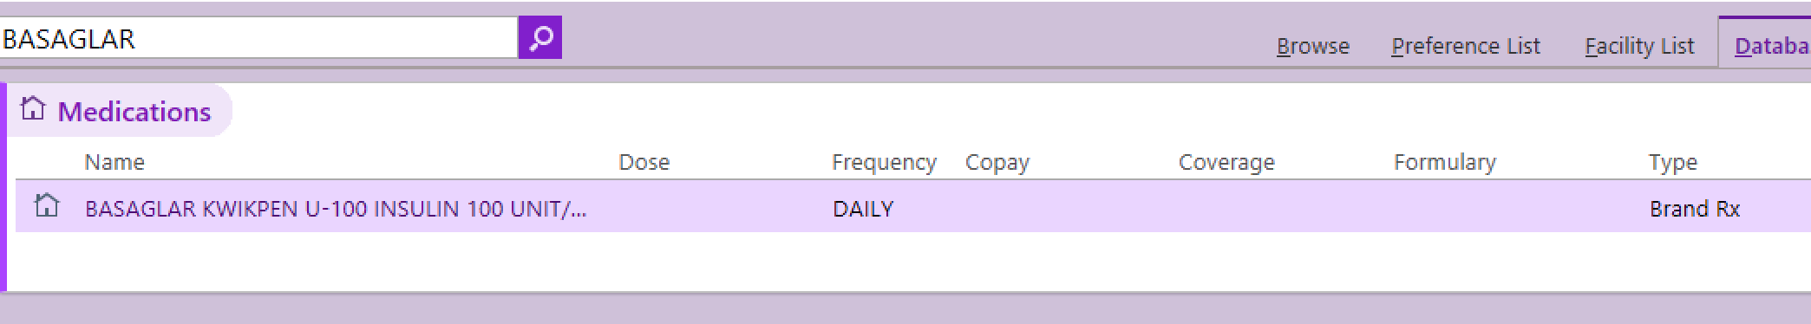

The patient sig (instructions) should look something like these:
- inject X units subcutaneously at bedtime
- X units Qhs

In addition to an English sig, you can also include a Spanish sig: “Inyecta X unidades antes de acostarse”. So the Sig would be: “Inject X units subcut every night. Inyecta X unidades antes de acostarse”. THIS IS NOT NECESSARY/REQUIRED but provider-preference dependent.

An example:
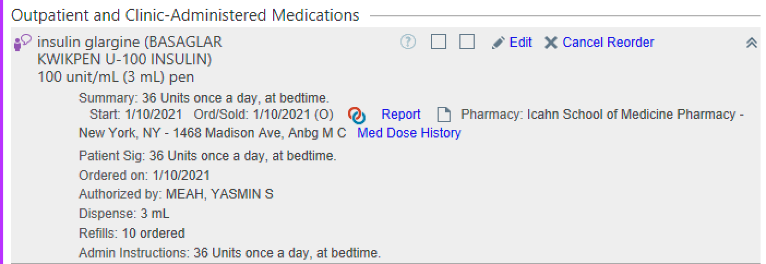

Generally, we have been prescribing patients about ~1-3 month of supplies. So, this patient is taking 36 U/day. That means 1080 U/month. For 3 months, that’d be 3240 U. Each box has 1500 U so 2 boxes (3000) works. So refills: 10 because 10 pens = 2 boxes.

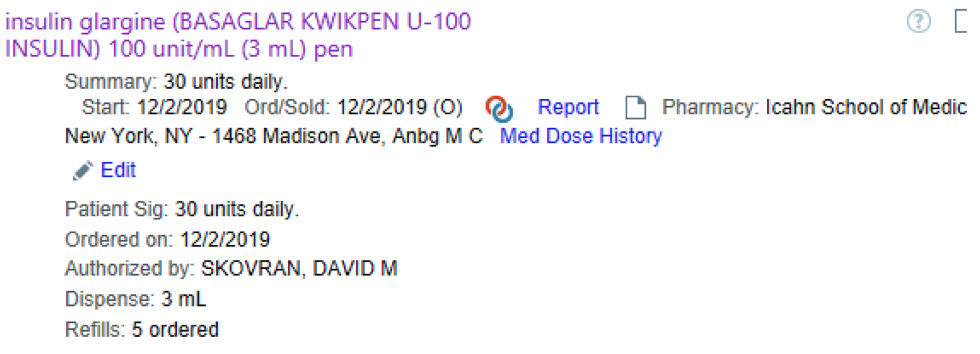

This is another example. This patient was ordered 1 box of pens. (Refills: 5)

If you have any questions, you can always ask me! I am super happy to answer anything

